Java Core Assessment

1. Implement your own abstract classes and interfaces.
Code : -
// Implement your own abstract classes and interfaces
package com.question1;
// Interface - Here methods are declared, but they should be called in class only by overriding
interface Parent {
void func();
}
// Class 1 - Abstract class with at least one abstract method
abstract class Base {
abstract void fun();
}
// Class 2 - Normal class that extends abstract class for function overriding
class Derived extends Base implements Parent {
void fun(){
System.out.println("Base's fun() from Derived class called");
}
public void func(){
System.out.println("Interface's func() from Derived class called");
}
}
// Class 3 - Main class
public class question1 {
public static void main(String[] args)
{
// Uncommenting the following line will cause compiler error as the line tries to create an instance of abstract class.
// Base b = new Base();
// We can have references of Base type.
Base b = new Derived();
Parent p = new Derived();
System.out.println();
b.fun();
p.func();
}
}

Output : -
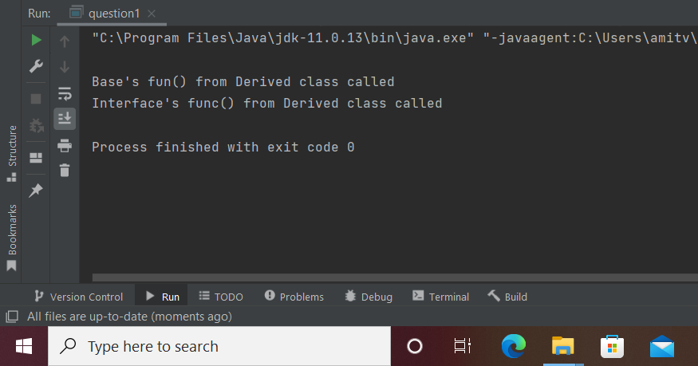

2. Implement your own encapsulating classes.
Code : -
// Implement your own encapsulating classes
package com.question2;
class EncapsulationDemo {
// private members so that they can only be called by methods within class
private int num1;
private int num2;
//getters and setters
public int getNum1() { return num1; }
public void setNum1(int num1) { this.num1 = num1; }
public int getNum2() { return num2; }
public void setNum2(int num2) { this.num2 = num2; }
}
public class question2 {
public static void main(String[] args){
EncapsulationDemo ed = new EncapsulationDemo();
ed.setNum1(5);
ed.setNum2(4);
System.out.println("\nMultiplication of two numbers is " + ed.getNum1() * ed.getNum2());
}
}

Output : -
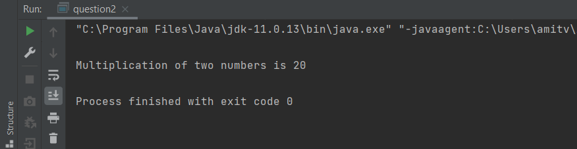

3. Create a thread named fetch Data using thread extend method
Fetch data should implement sleep method with 5000ms time
Create a thread named processData using runnable interface
Make sure processData starts its execution only after fetchData
thread has completed its execution with the timeout of 10000ms
Code : -
// Create a thread named fetch Data using thread extend method
// Fetch data should implement sleep method with 5000ms time
// Create a thread named processData using runnable interface
// Make sure processData starts its execution only after fetchData
// thread has completed its execution with the timeout of 10000ms
package com.question3;
class FetchData extends Thread{
@Override
public void run() {
System.out.println("\nMyThread - START "+Thread.currentThread().getName());
try {
Thread.sleep(5000);
System.out.println("FetchData thread is running......" + Thread.currentThread().getName());
} catch (InterruptedException e) {
e.printStackTrace();
}
System.out.println("MyThread - END "+Thread.currentThread().getName());
}
}
class ProcessData implements Runnable{
@Override
public void run() {
System.out.println("\nDoing heavy processing - START " + Thread.currentThread().getName());
try {
Thread.sleep(10000);
System.out.println("ProcessData thread is running...... " + Thread.currentThread().getName());
} catch (InterruptedException e) {
e.printStackTrace();
}
System.out.println("Doing heavy processing - END " + Thread.currentThread().getName());
}
}
public class question3 {
public static void main(String[] args)throws InterruptedException{
FetchData fd = new FetchData();
Thread t1 = new Thread(new ProcessData(), "Thread-1");
fd.start();
fd.join();
t1.start();
t1.join();
}
}

Output : -
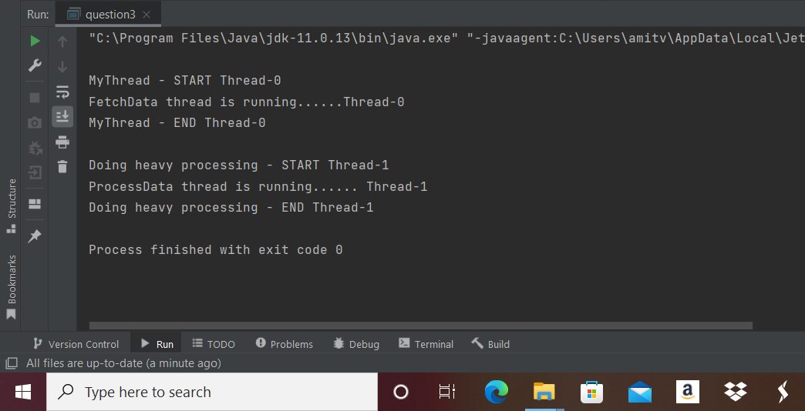

4. Create a resource called message
○Message will have text as the field and isEmpty as the condition
○It has two synchronized functions read and write
●Create a writer thread that writes resource
●Create a reader thread that reads resource
Code : -
//Create a resource called message
// ○Message will have text as the field and isEmpty as the condition
// ○It has two synchronized functions read and write
// ●Create a writer thread that writes resource
// ●Create a reader thread that reads resource
package com.question4;
class Message {
private String data;
synchronized void writeData(String str) {//synchronized method
this.data = str;
}
synchronized void readData() {//synchronized method
System.out.println(data);
}
}
class Writer extends Thread{
Message t;
Writer(Message t){
this.t=t;
}
public void run(){
t.writeData("\nHello World");
}
}
class Reader extends Thread{
Message t;
Reader(Message t){
this.t=t;
}
public void run(){
t.readData();
}
}
public class question4 {
public static void main(String[] args){
Message obj = new Message();
Writer t1=new Writer(obj);
Reader t2=new Reader(obj);
t1.start();
t2.start();
}
}

Output : -
